

**ALAGAPPA COLLEGE OF TECHNOLOGY**

**ANNA UNIVERSITY-600025**

**NM Assignment / Digital Marketing**

| NAME | REG.NO | Naan Mudhalvan ID |
| --- | --- | --- |
| M Jagadeesh Sai | 2020308016 | 13F2B0EE464BCD68CC44344674C77A89 |

**1. Create a blog or website using Blogpost Customize the theme design and post new article with 500 words.**

[Things to do when you are bored !! (lifeasweseeirl.blogspot.com)](https://lifeasweseeirl.blogspot.com/2023/10/things-to-do-when-you-are-bored.html)

**2. Create a New Facebook Business Page and post one social media poster for your brand.**

[Luxebrew | Chennai | Facebook](https://www.facebook.com/people/Luxebrew/61552558247945/?is_tour_dismissed=true)

**3. Create and design a social media advertisement poster using canva.**

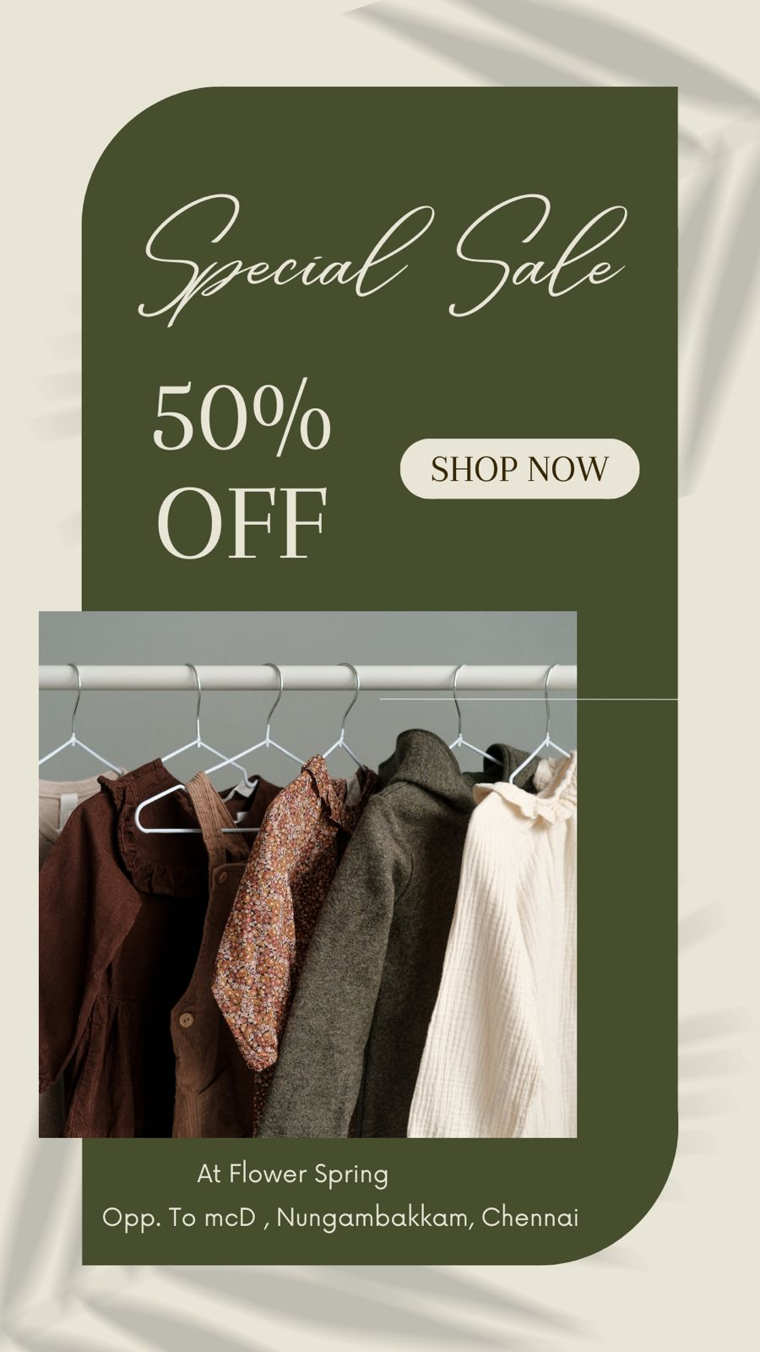

**4. Create email newsletter design using MailChimp or canva tool.**

